CCNP ROUTING AND SWITCHING



AWS EC2

Instance

B Brennen Tse . 2/21/2022

Task 1: Launch Your Amazon EC2 Instance

1. Choose EC2 from the AWS Management Console on the Services menu
2. Launch Instance from the Instance button in the top left
3. Choose the Amazon Linux 2 AMI and Select it.
4. Choose a t2.micro instance and choose next: configure instance details in the bottom right
5. Select Lab VPC and protect against accidental termination

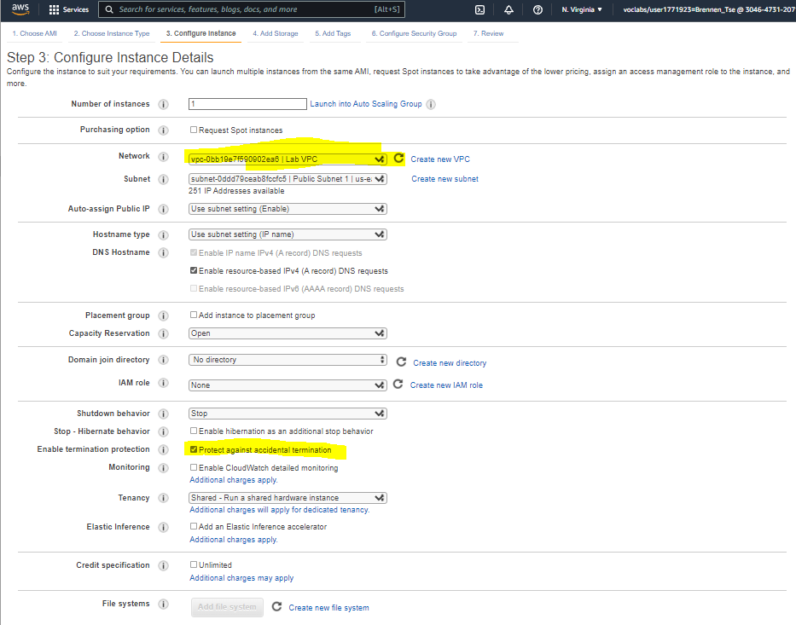

1. Expand advance details on the bottom and paste the command into the user data field:

#!/bin/bash

yum -y install httpd

systemctl enable httpd

systemctl start httpd

echo '<html><h1>Hello From Your Web Server!</h1></html>' > /var/www/html/index.html

This command installs a web server, configures it, activates and creates a web page.

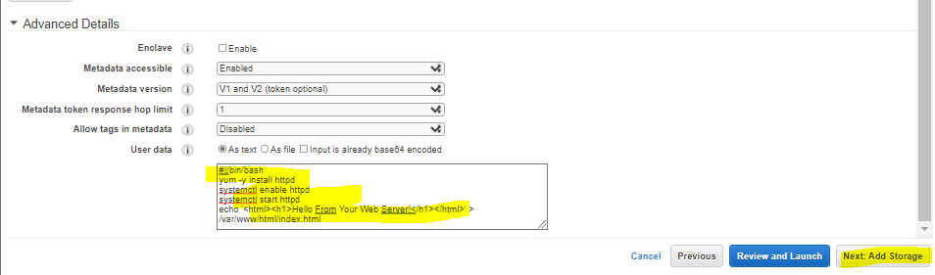

1. You do not have to worry about adding storage, choose next: add tags
2. Select Add Tag and configure a key of Name and Value of Web Server, then click next.

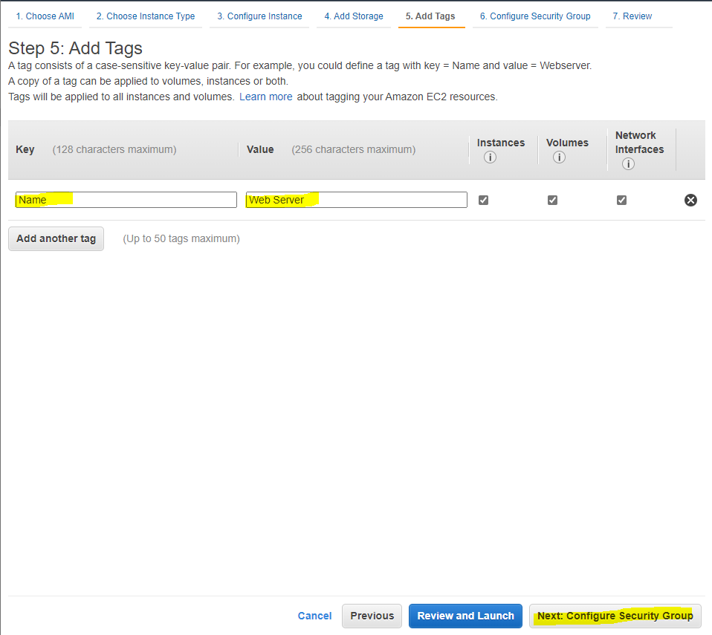

1. Configure the security group with a name of Web Server security group and a description of Security group for my web server. Remove SSH access for security. Then click review and launch

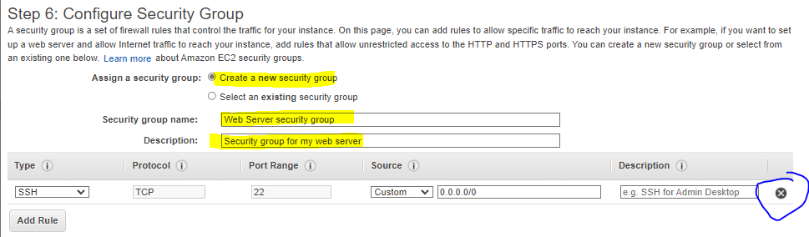

1. Select Launch, choose proceed without a key pair. Click the necessary popups and launch the instance, then view it.

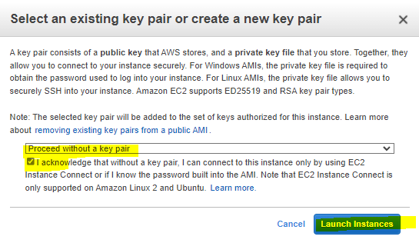

1. The instance will initially be pending but once the state changes to running, you know the EC2 instance is working.

Task 2: Monitor Your Instance

1. Choose the Status Checks Tab by clicking on the instance and selecting the 5th tab that appears, then the 6th Monitoring tab then in the actions menu select Monitor and troubleshoot, retrieve the system log. 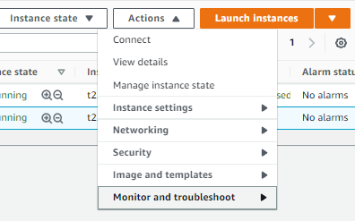
2. Look at the output and choose cancel

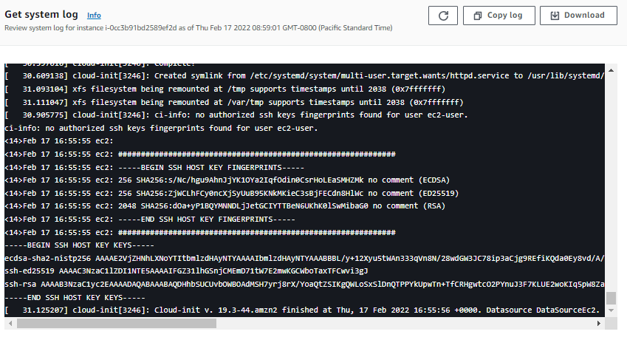

1. In the Actions menu select Monitor and troubleshoot then get a screenshot. Then click cancel.

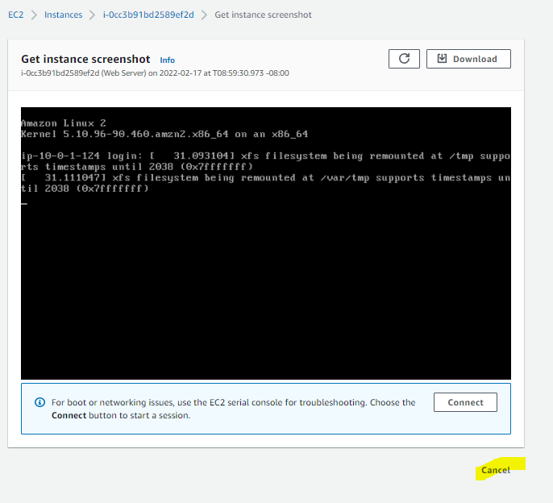

Task 3: Update Your Security Group and Access the Web Server

1. Choose the Details tab after clicking the instance
2. Copy the IPV4 Public IP of the instance
3. Open a new tab and paste the ip address
4. You won’t be able to access the web server so return to the EC2 Management Console.
5. On the left, choose security groups
6. Choose Inbound rules, edit inbound rules and configure:

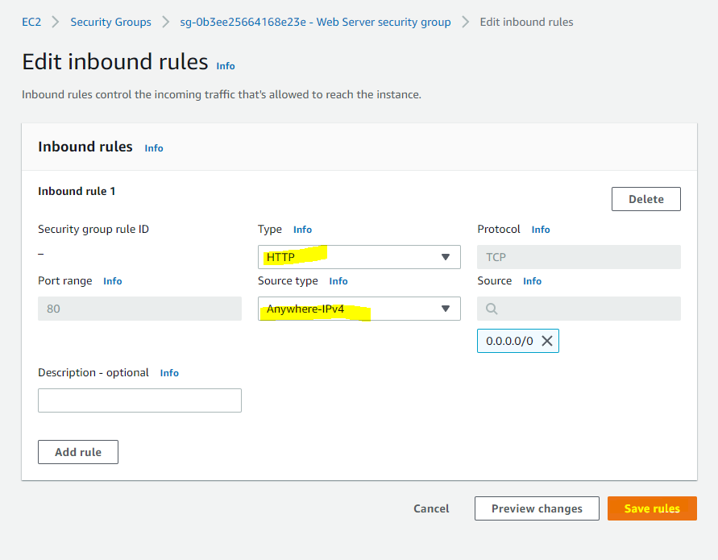

1. The webpage should now display: 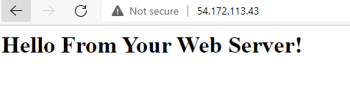

Task 4: Resize Your Instance: Instance Type and EBS Volume

1. Stop the instance to resize it. Select Instances from the left and in the Instance State menu Stop instance.

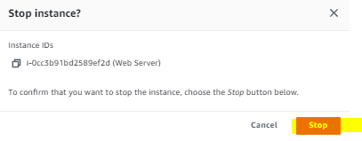

1. Change the instance type by going to the actions menu, selecting instance settings, changing the type, then configuring: 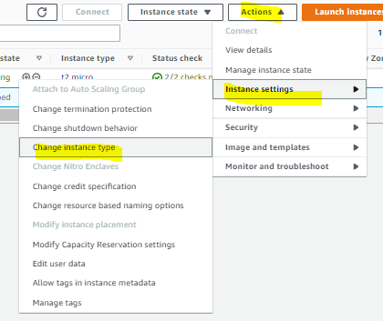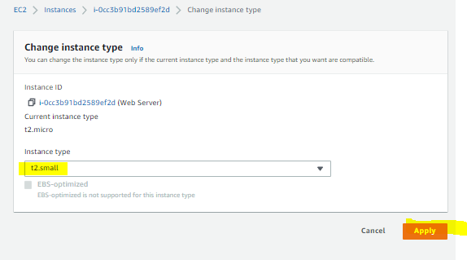
2. Resize the volume from the left volumes tab.

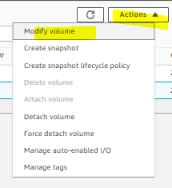

1. Change disk volume to 10 GiB and choose modify and yes.

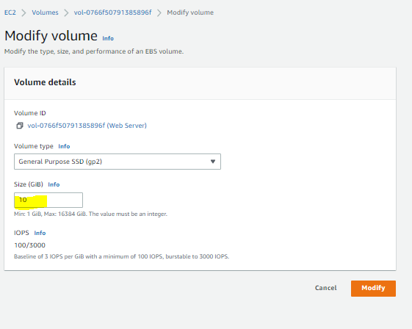

1. Restart the Instance by clicking on Instances, Start Instance from the instance menu and start.

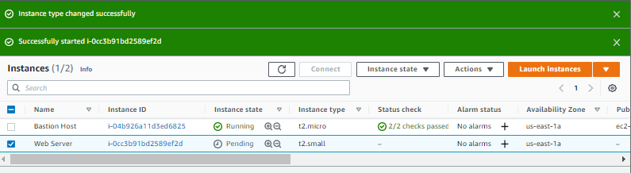

Task 5: Explore EC2 Limits

1. Choose limits from the left and select running instances from the drop down list.

Task 6: Test Termination Protection

1. DO this by selecting Instances again, and from the instance state menu try to terminate the instance. It should fail and give this message: 
2. In the actions menu select instance setting and turn off termination protection, save it and try to terminate it again, it should work this time.

